# Apple-o-matic Service Feasibility Evaluation

April 2015

The Apple-o-matic Service spring term integrative project proposal includes the following scope:

Deliver proof-of-concept with feasibility evaluated in one community by end of Spring Term.

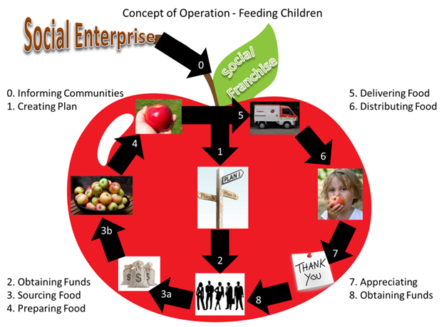The Feasibility Evaluation will consist of tests to verify high risk architecture decisions that overcome design challenges related to the function of distributing food (Step 6 in Concept of Operation).

The MIT SDM Team 25 will conduct a field test using prototype software along with survey questions as part of the feasibility evaluation. The following important quality attributes are the areas of focus and desired outcomes are planned for this Feasibility Evaluation.

1. **Students hungry when provided apples –** Apple acceptance and impact of satiation depends on timeliness of feeding time. The desired outcome is to demonstrate hunger is a need by the child in the afternoon.
2. **Acceptance of the apples by students** – Apple rate of distribution is a challenge that may limit the viability of the solution. The desired outcome is for > 20% of students to take apples daily. (Based on DC3 intended outcome to increase student fruit consumption by 20% in participating school.)
3. **Responsive donor network for acquiring apples** – Apple rate of sourcing is a control input that varies based on identified recipients. The desired outcome is to demonstrate the donor network can be notified of student consumption changes with <1 day delay in the system to minimize the inventory. (Based on OS17 DSM analysis, we had already realized that a need must be identified prior to triggering donations, but not that recipients had to be identified prior to acquiring the food from the source in order to process for spoilage reasons.)

The Feasibility Evaluation shall consist of the following activities for each test day:

1) Daily survey administered by teachers to record student response



2) Use Apple-o-matic system proof-of-concept prototype to verify the feasibility around 2pm

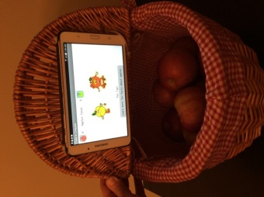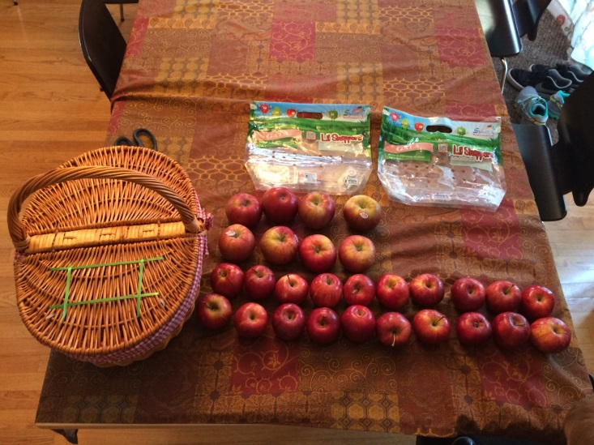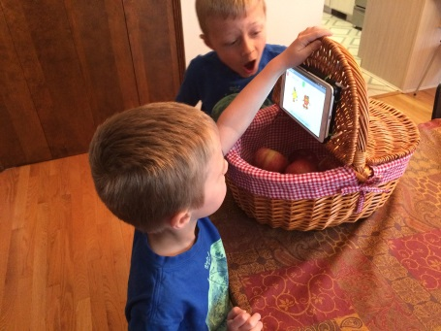

1. Load Basket with apples (22-25 small)

2. Start App

3. Distribute Apples

Each student will perform the following steps to distribute the apples:

1. Open the basket lid
2. Hear a special educational message about apples
3. Take an apple to eat
4. Lower the lid for next student

3) Teacher self-survey to measure outcomes



The following system will be created for evaluation.

ApplePi - The Apple Prepared Inventory (ApplePi) shall be implemented with a low cost android tablet with following software written using [MIT App Inventor](http://appinventor.mit.edu/explore/) , a picnic basket and hinged lid on basket with tablet mounted on the inside (closed side) of lid:

1. The Apple Distributor component shall play “Enjoy an apple for a healthy snack” audio with logo for apple awareness upon opening the basket lid.
2. 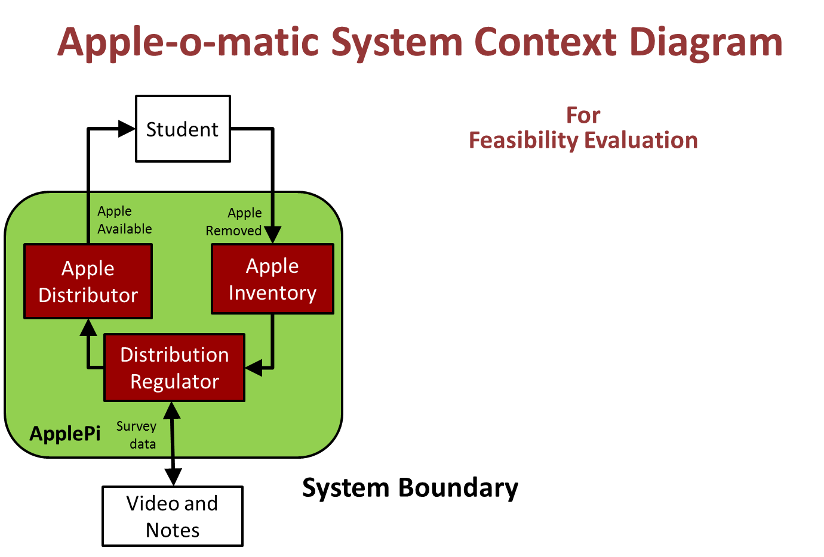Apple Inventory – Check if apples are available in distribution machine
3. Distribution Regulator – Logs events to files to compliment survey data.

The estimated cost will be ~$0.45/apple. 5-day study with 22 kids will cost ~$50. These apples will be sourced from local Hy-Vee or Dubuque Food Coop through donation from Aaron Vesperman.

The feasibility evaluation will be conducted at Irving Elementary School in Dubuque Iowa on April 27-May1, 2015. Aaron Vesperman is in contact with his son’s first grade teacher Meredith Schmechel [mschmechel@dbqschools.org](mailto:mschmechel@dbqschools.org) to organize the evaluation. The feasibility evaluation is being discussed and confirmed with the school.

References:



**Fun Facts** – Students will hear these educational phrases from usapple.org about Apples after counter increments. App is designed for use on Android 7” tablets.

1. An apple a day keeps the doctor away.
2. Apples fill you up.
3. Apples boost brain power.
4. During the winter apple trees have no leaves, no flowers and no apples.
5. In the fall apples are ripe enough to pick for you to enjoy.
6. Apples are grown in every state in the continental U S
7. Each apple is hand picked by people using ladders and cloth buckets.
8. Apples are a delicious, convenient and nutritious super food found in every supermarket
9. Because of apples’ high fiber content, the fruit’s natural sugars are slowly released into the blood stream, helping maintain steady blood sugar levels.
10. Irving elementary students are making healthy eating choices today!
11. Apples come in many varieties
12. Apples are an easy way to eat more fruits each day for a healthy diet.
13. Apples are convenient – Mother Nature’s original fast foods
14. Apples are nutritious and a very good fruit for building healthy bodies.

**App Screenshots** – Press “Go” to start “Apples Taken” counter for use in distribution with basket.

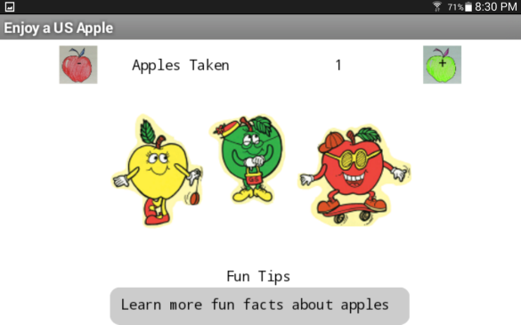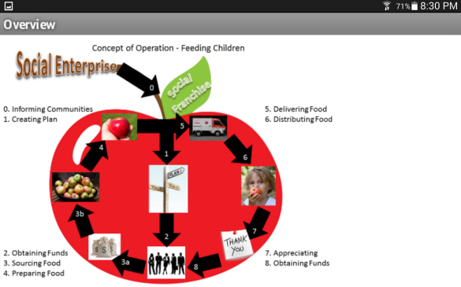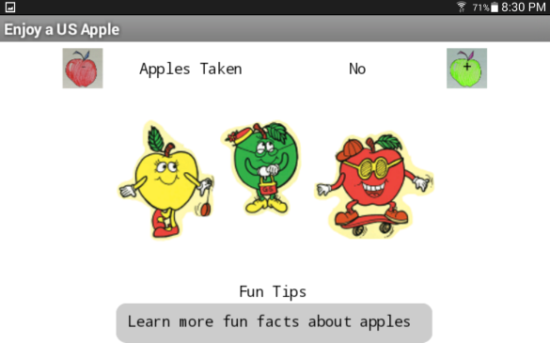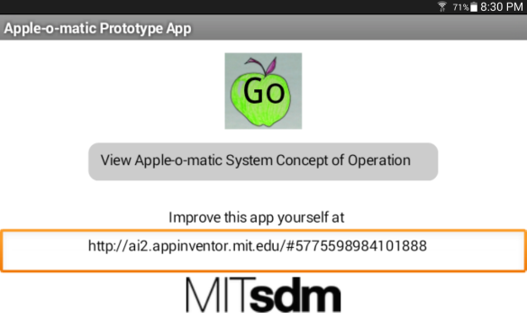

VDA Decision Process from Taming Diabetes *with Systems Thinking by* ***Carlos o. Morales***

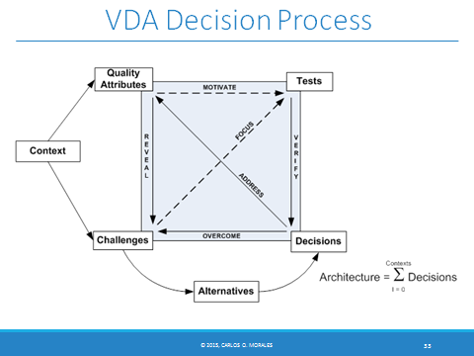

INCOSE handbook v3.2.2 2011 page 39

**3.3.2 Concept Stage**

The Concept Stage is a refinement and broadening of the studies, experiments, and engineering models pursued during the Exploratory Research Stage. The processes described in this handbook are requirements‐driven, as opposed to product‐driven. Thus, the first step is to identify, clarify, and document stakeholders’ requirements. If there was no Exploratory Research stage, that effort is done here.

During the Concept Stage, the team begins in‐depth studies that evaluate multiple candidate concepts and eventually provide a substantiated justification for the system concept that is selected. As part of this evaluation, mockups may be built (for hardware) or coded (for software), engineering models and simulations may be executed, and prototypes of critical elements may be built and tested. Prototypes are helpful to verify the feasibility of concepts, to aid the understanding of user needs, and to explore risks and opportunities. These studies expand the risk and opportunity evaluation to include affordability assessment, environmental impact, failure modes, hazard analysis, technical obsolescence, and system disposal. The systems engineer facilitates these analyses by coordinating the activities of engineers from many disciplines. Key objectives are to provide confidence that the business case is sound and the proposed solutions are achievable.